A Tapered Quad Laminates

Stephen Tsai
Stanford University

September 12, 2025

Quad laminates cannot be tapered to save weight is caused by the complexity in their stacking sequence when the building blocks used are 8-, 10- or higher number of plies. When mid-plane symmetry is added, the ply numbers are doubled. There are additional plies added to meet the load-carrying requirements. Such laminates cannot be tapered because laminate properties are changed when plies are dropped. The most effective way for tapering is homogenization.
This is done by stacking identical building blocks in sufficiently large number so the laminate in-plane stiffness [A*] is equal to the flexural stiffness [D*], and coupling matrix [B] approaches zero. We have discovered one Quad laminate that can be homogenized and then tapered. Quad laminates have two advantages over DD because of the availability of extensive data, and familiarity of design practices.

Quad laminate has 4 plies as the lowest ply number. The resulting laminate is limited to have quasi-isotropic properties. Also there are 12 different stacking sequences as seen in the slide below. The stiffness values are trace-normalized. There are 12 more laminates with the signs of [±45] interchanged. The listing of the laminates shown in the slide below is based on the descending order of D₁₁*.
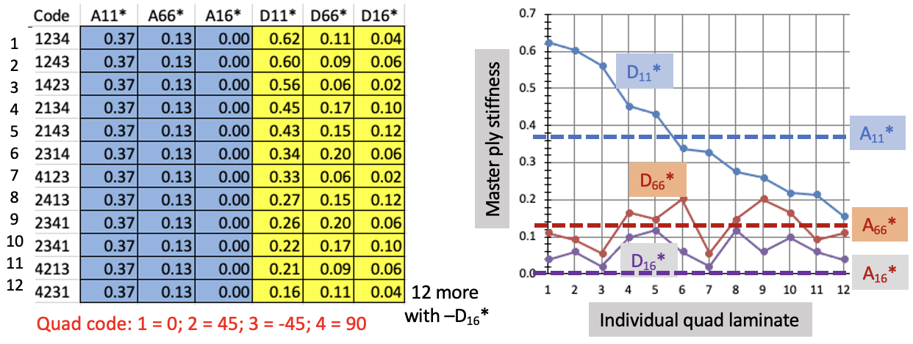

To homogenize this 4-ply Quad laminates, each building block must repeatedly stacked. The resulting stiffness is shown in the slide below. The rate of convergence of D₁₁* to in-plane stiffness A₁₁* vary, and the fastest in #6 in [±45/0/90]. The number of repeats for homogenization is about 5. Once a laminate is homogenized it is possible to be tapered.
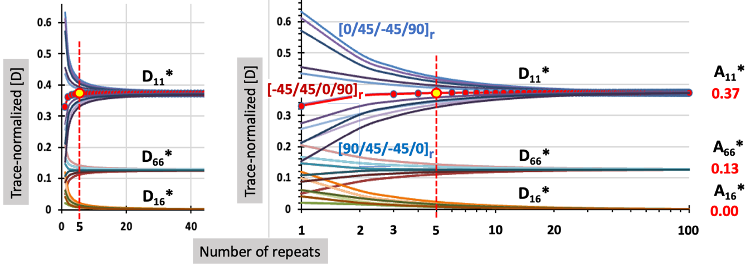

The convergence of flexural to in-plane stiffness is shown for in the upper left in the slide below. Three diagonal flexural components of this quasi-isotropic laminate are shown. This stacking sequence of [±45/0/90] has the fastest convergence. At a repeated number 5, reasonable convergence is found. This particular stacking can be made with two most common building blocks in [±45] and [0/90]. It is truly a black aluminum. It is like a metal that should be much easier to design than orthotropic laminates.

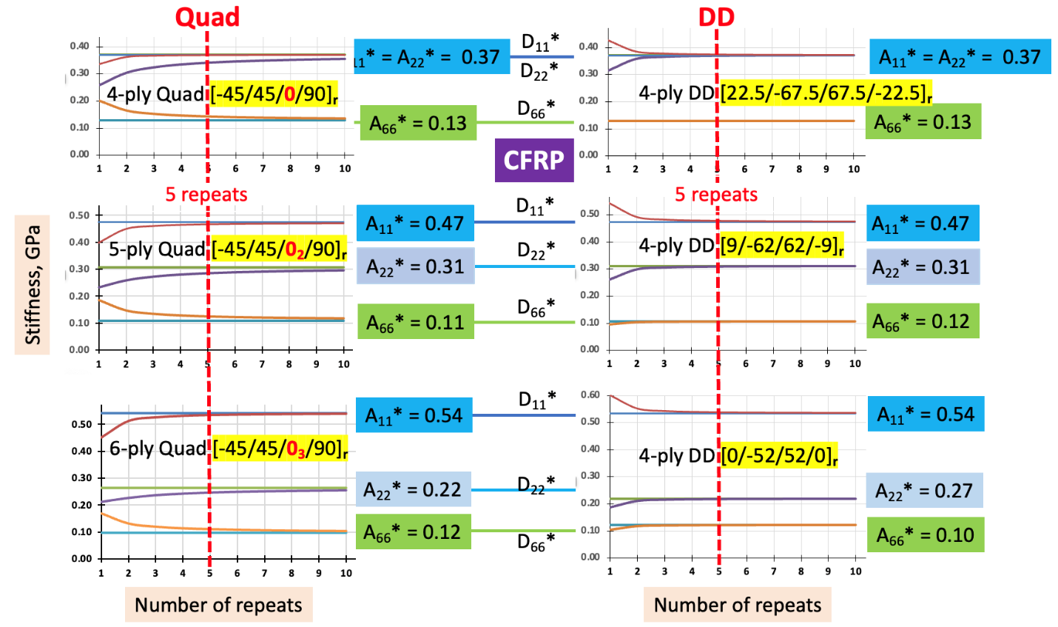

It turned out that two orthotropic laminates can be derived from this quasi-isotropic laminate. This is done by adding one or two [0] plies to the single [0] in this unique laminate. The total number of plies will increase to 5 and 6. Plies are added so the stacking sequence does not change. Shear stiffness can be increased is both [+45] and [-45] are added in units of single plies. These specific ply adding rule must be followed so the homogenization of plies remain the same. While these orthotropic laminates serve their purposes, their properties are limited; not suitable for general use. The quasi-isotropic case is unrestricted and can be used for all situations.

Homogenized Quad offer the following structural benefits found in DD.

- Laminates built with multiple repeated stacking can become homogenized. They can be tapered by reducing the weight by reducing the number of repeats like from 12 to 11 to10 …
- Having small number of plies per building plots (from 4 to 6 covered so far) thin plies can be effectively use to build the pre-plied laminates with sufficient thickness suitable for tape laying machine, and desired laminate thickness for minimum gage.
- Such tape can have 1-axis layup, without cross-plying. The rate of tape deposition can be 6X that of traditional Quad that is laid one ply at a time.
- Traditional design rules like mid-plane symmetry, balanced laminate, 10-percent rule, stacking sequence rule, and ply nesting are either automatically satisfied or no longer relevant.

While homogenized Quad laminates are shown, they are limited in number. In fact, only 3. Their properties are limited in scope. Double-double on the other hand covers the entire field from 0 to 90 degree for each of the 4 ply angles. In addition, its convergence from flexural to in-plane is faster than those of the 3 Quad shown on the right half of the figure above. The Quad proposed herein has limited scope in properties on orthotropy (in only 2 cases), while its quasi-isotropic case is limited by each material. Having confidence in the design allowable of Quad allows designers to use these unique Quad to learn the benefits of homogenization. This is one way to be exposed the benefits of DD to non-believers.

Strength shown in the slide below is one way to show the benefits of the design, testing and manufacturing of DD. Tsai-Wu failure criterion with omni envelope is used. The ply and laminate strength data used here were measured by Waruna Seneviratne NIAR for the National Center for Advanced Materials Performance (NACAMP). Good correlation between ply strength in X and X’ (uniaxial tensile and compressive strengths of [0]) and uniaxial laminate strengths in X and X’ was found through Tsai-Wu failure criterion. In the slide 3 materials in T800/Cyt, T4708 and T300/F35 are selected. They represent the upper bound, the average or master ply, and the lower bound strength of CFRP. All other CARP should fall between the two bounds. For each material 3 laminates were selected: Quasi-isotropic in [±45/0/90] and 2 orthotropic Quad in [±45/0₂/90] and [±45/0₃/90]. They are the same ones selected in the slide above where their convergences from flexural to in-plane stiffness were the fastest among the 4-ply Quad laminates. For the matching DD of the 3 Quad laminates are shown in the slide above 3 DD are shown: [22.5/67.5], [9/62] and [0/52], respectively. So in the slide below, There are 3 materials and 3 laminates.

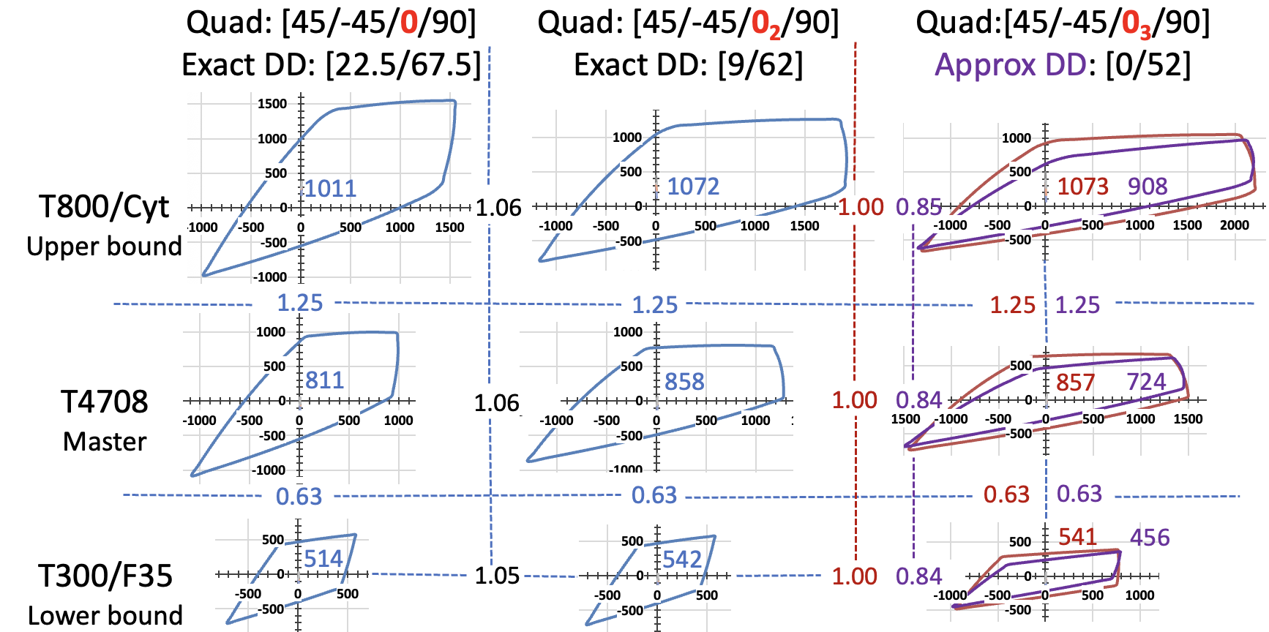

The average strength or radius R of the circle with equal area of each LPF envelope is shown in the number placed next to the origin. For the first 2 laminates of each material, the Quad and DD are identically equal. Their envelopes are shown in one single blue envelope. Their ratios for the first 2 material are 1.06 (= 1072/1011), and the last material 1.05 (= 542/514). Thus their accuracy is 1 percent. For the 3rd material in T800/Cyt the Quad and DD do not match exactly. They are approximate and have 2 values of for their R values, in 1073 and 908, respectively. But their ratios over the center laminate in the slide are 1.00 or 0.85 (or 0.84). Again they are with 1 percent accuracy.

If we wish to compare the relative strength of materials, T800/Cyt is 25 percent higher than T4708 for all 3 laminates, with no error. That ratio between T300/F35 and T4708 is 0.63 for all 3 laminates, without error. These correlations are amazing and can simplify material property tests. We have also claimed that ratios of laminate strength between 2 materials are the same for all materials.

Materials and laminates are independent and are locked in within 1 percent variation. Experimental variation can be 3 or higher percent. How would the number of tests be determined. We believe that it showed that our empirical correlation is correct. It implies that our omni envelope, matrix degradation to model micro cracking, and Tsai-Wu failure criterion for LPF based on only X and X’ (not include Y, Y’, and S) are correct.

The prediction of laminate strengths in X and X’ from the LPF envelope as described is shown in the slide below. The red envelope is the predicted LPF Tsai-Wu while the circular dots are the uniaxial tensile and compressive data. There were 8 materials and 4 laminates. There were data from 9 quasi-isotropic laminates and they showed the best correlation between our prediction and confirming data.

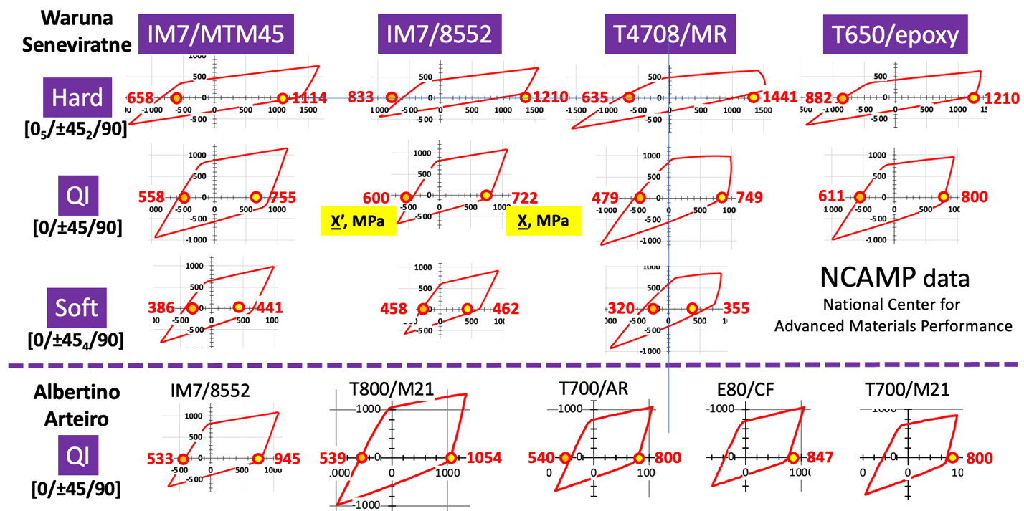

We see an opportunity for engineers to explore a new feature of Quad laminates that can be homogenized and tapered. The exciting opportunities in innovative design, testing and manufacturing easily done with DD can now be done with special Quad. The best of both world is now possible. To have homogenized Quad with confidence of design data allowable and procedures combined with nearly all the features of simplicity and light weight of DD. While only 3 Quad laminates are offered for this unique application, it is not limited by such. Others Quad can be found. More importantly, the door to DD can now be opened.

For those interested in having tools for plotting failure envelopes and books on DD, please contact us at stsai@stanford.edu.

